**STATIC WEB DESIGN**

**USING HTML**

**LAB # 0****2**

**Spring 2025**

**CSE-403L**

**Database Management System Lab**

Submitted by: **Naveed Ahmad**

Registration No.: **22PWCSE2165**

Class Section: **‘B’**

“Honesty is the best policy!”

Student Signature: ______________

Submitted to:

**Engr. Sumayyea Salahuddin**

Wednesday, 19 feb, 2024

Department of Computer Systems Engineering

University of Engineering and Technology, Peshawar

**Lab Tasks**:

**Task 2.1**: *Read the lab document. Do as directed*:

1. **How HTML can be helpful for a SQL/NoSQL database? Write a short note on the paper.**

We know that the data is stored at database.The question arise how we view that data or how can we access the data from database.So that access is provided by web that is why we use html..

1. ***Practical 1:*****Understand and go through all the 17 examples provided in this lab. Try each one in your favorite IDE. Check output in browser…..**

Example 01:

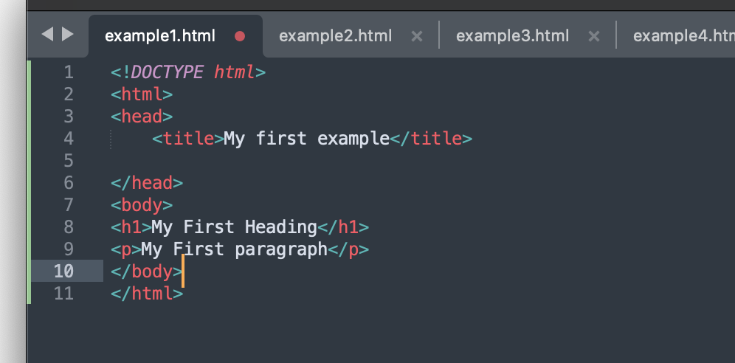

* Demonstrates a simple web page structure using basic HTML tags (<html>, <head>, <title>, <body>).
* Includes a heading (<h1>) and a paragraph (<p>).
* Shows how to use comments in HTML (<!-- comment -->).

Output:

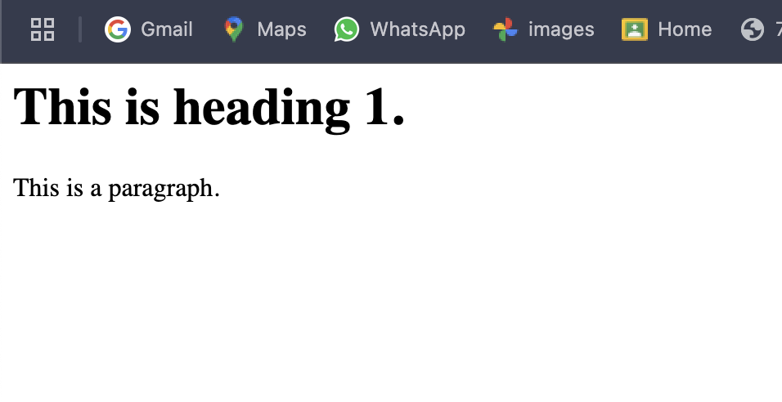

Example 02:

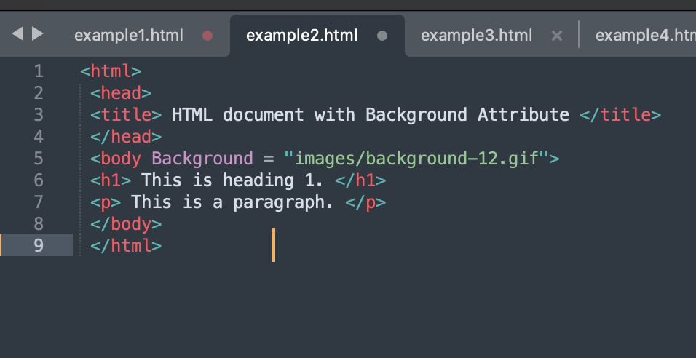

* Demonstrates using attributes in HTML tags.
* The background attribute is used to set a background image for the web page.

Output:



Example 03:

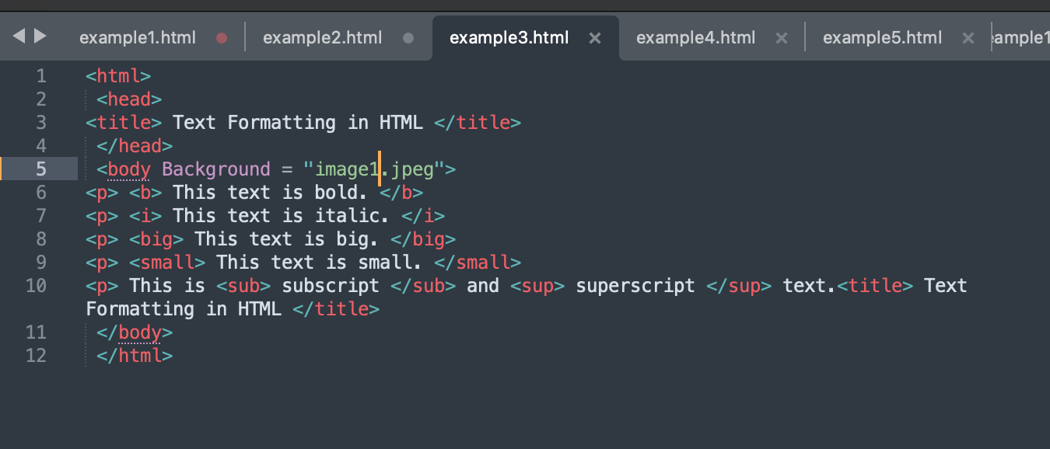

* Illustrates the use of various text formatting tags like <b>, <i>, <big>, <small>, <sub>, and <sup>.
* how to style text with basic tags for emphasis and size.

Output:

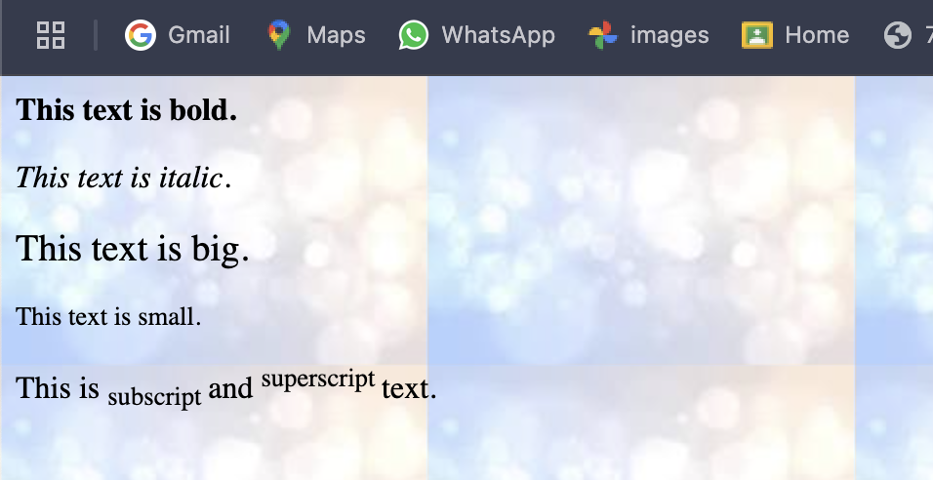

Example 04:

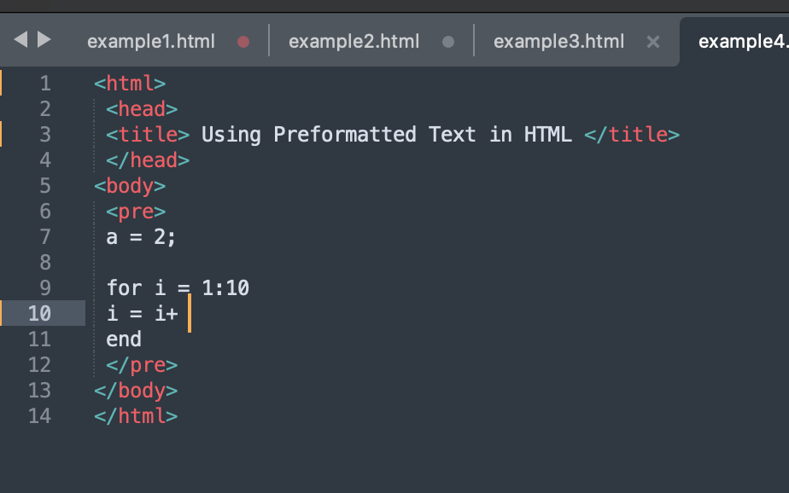

* emonstrates the use of the <pre> tag for preserving whitespace and formatting text or code.

Output:

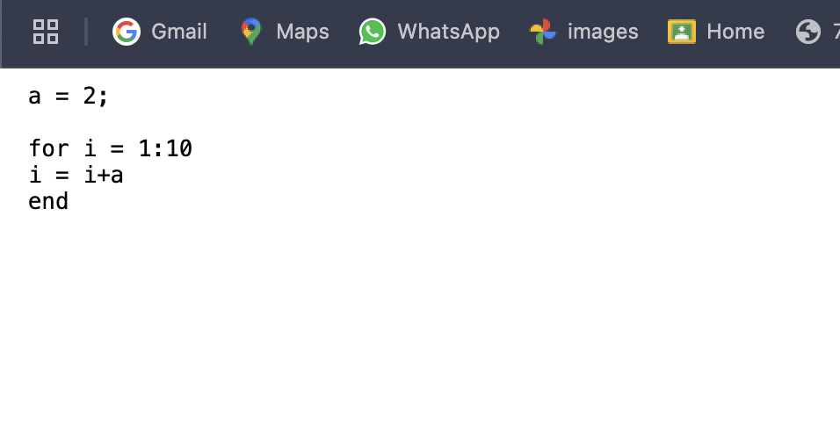

Example 05:

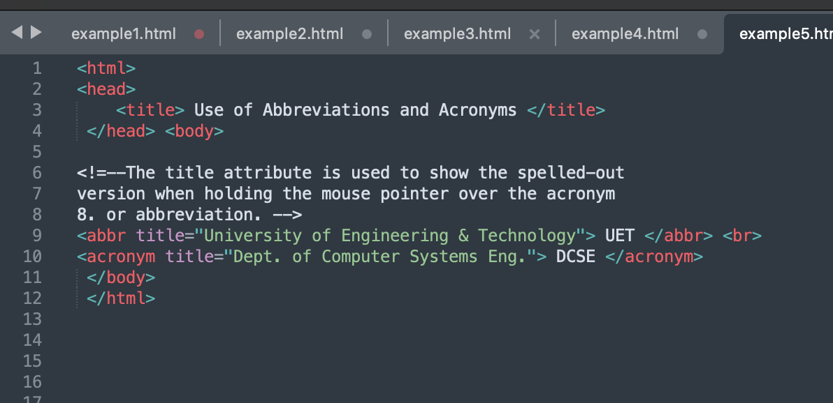

* Shows how to use the <abbr> and <acronym> tags to display abbreviations and acronyms with tooltips

Output:

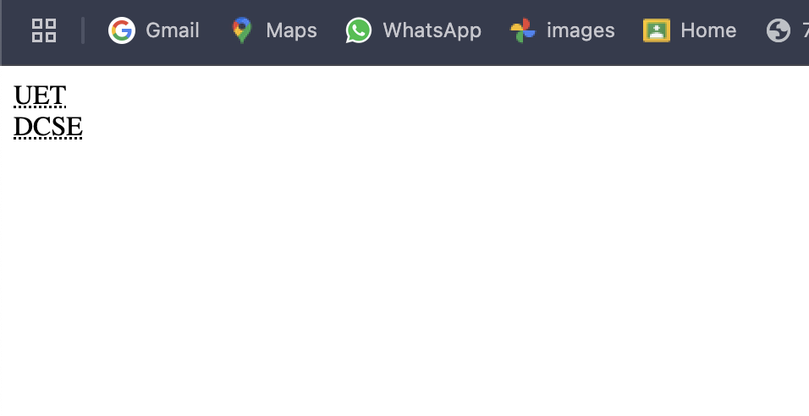

Example 06:

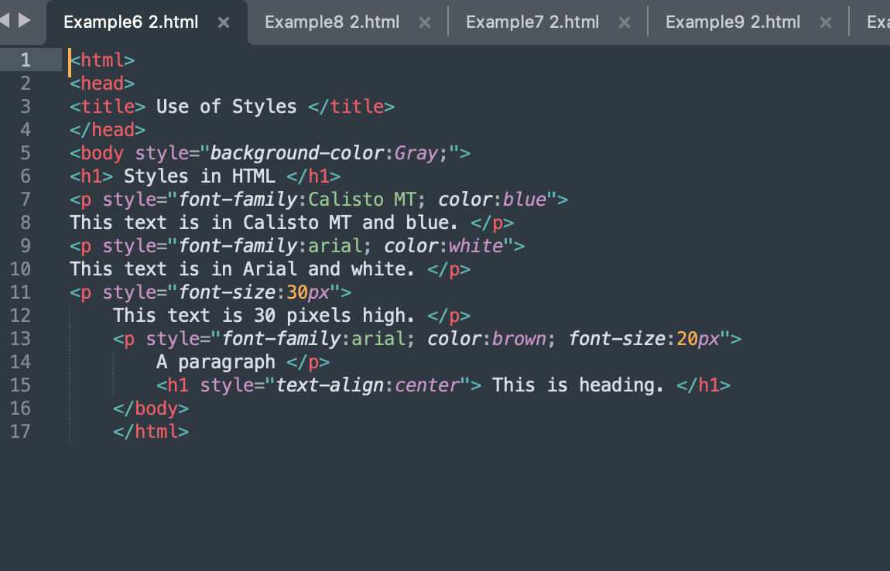

* Demonstrates the use of inline styles to change background color, font family, font size, color, and text alignment.

Output:

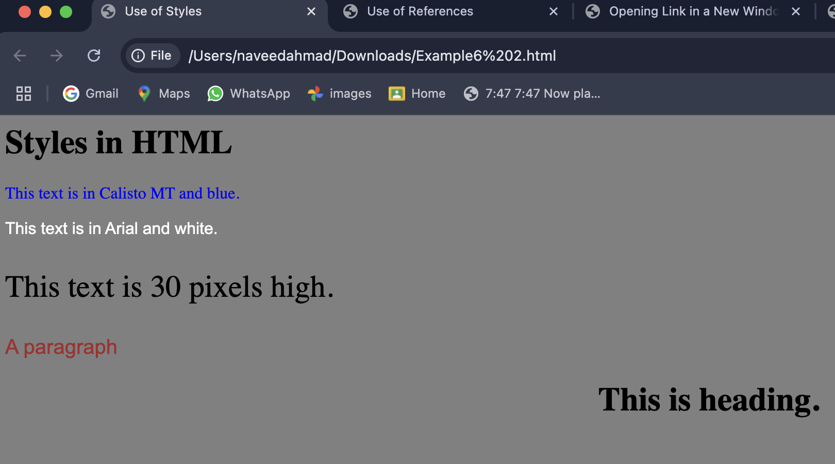

Example 07:

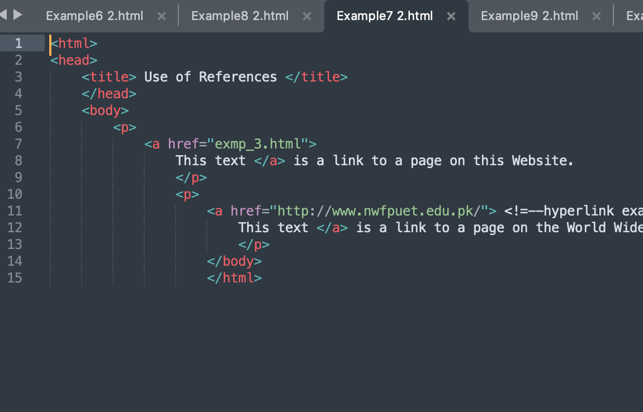

* Shows how to create hyperlinks using the <a> tag.
* Demonstrates links within a website and external links to the web.

Output:

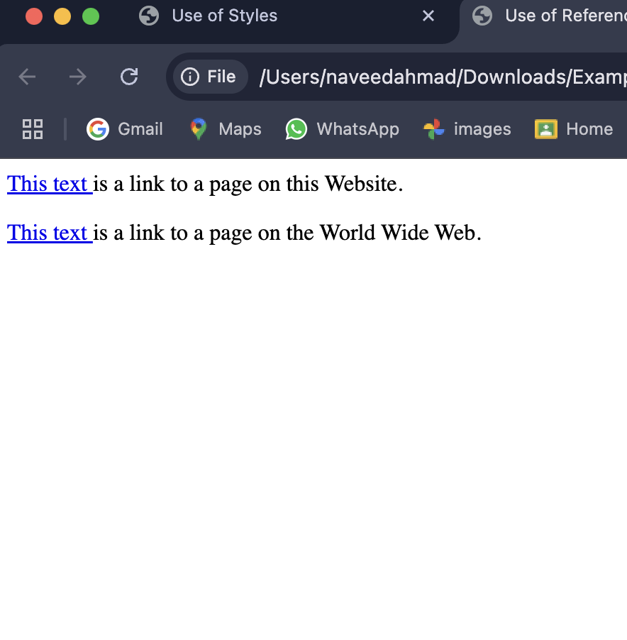

Example 08:

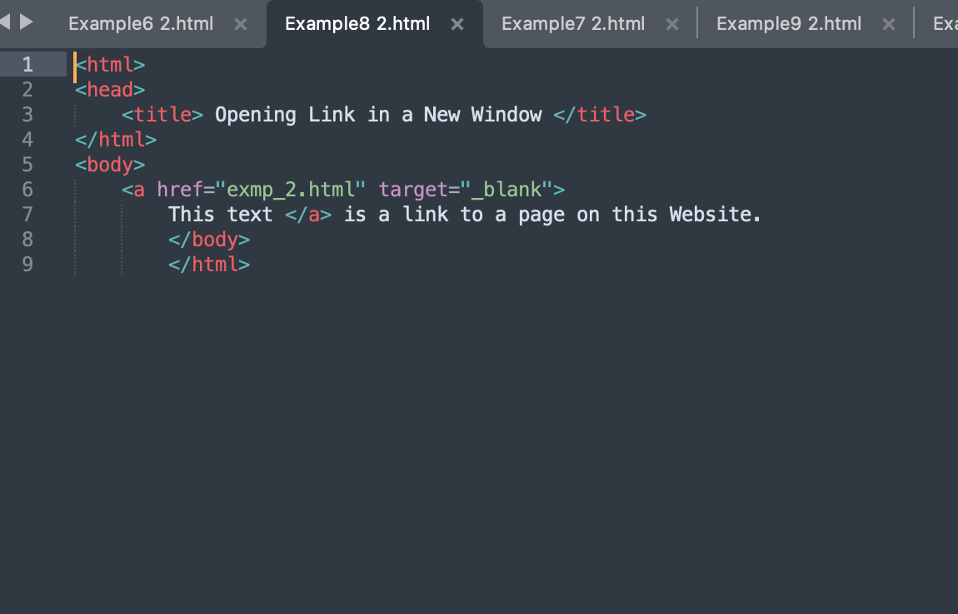

* Demonstrates the target="_blank" attribute to open links in a new browser window or tab.

Output:

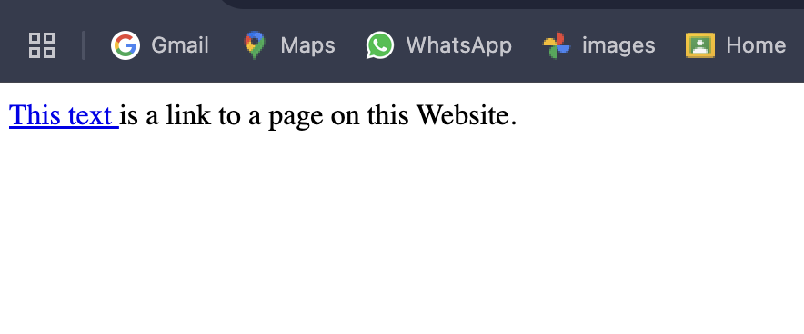

Example 09:

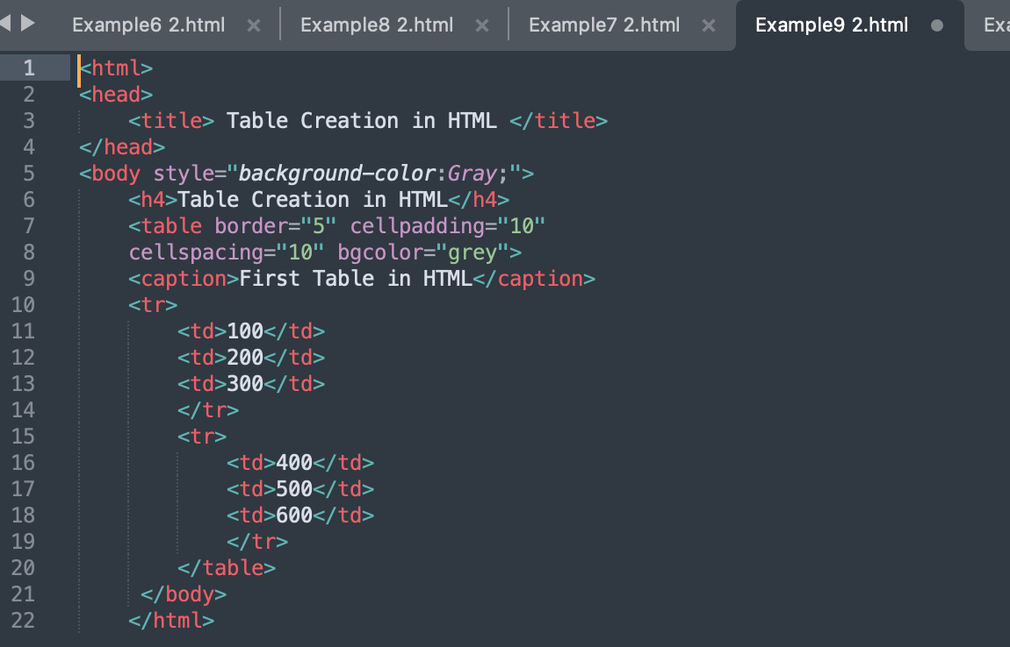

* Demonstrates basic table creation using <table>, <tr>, <td>, and <caption> tags.
* Includes attributes like border, cellpadding, and cellspacing.

Output:

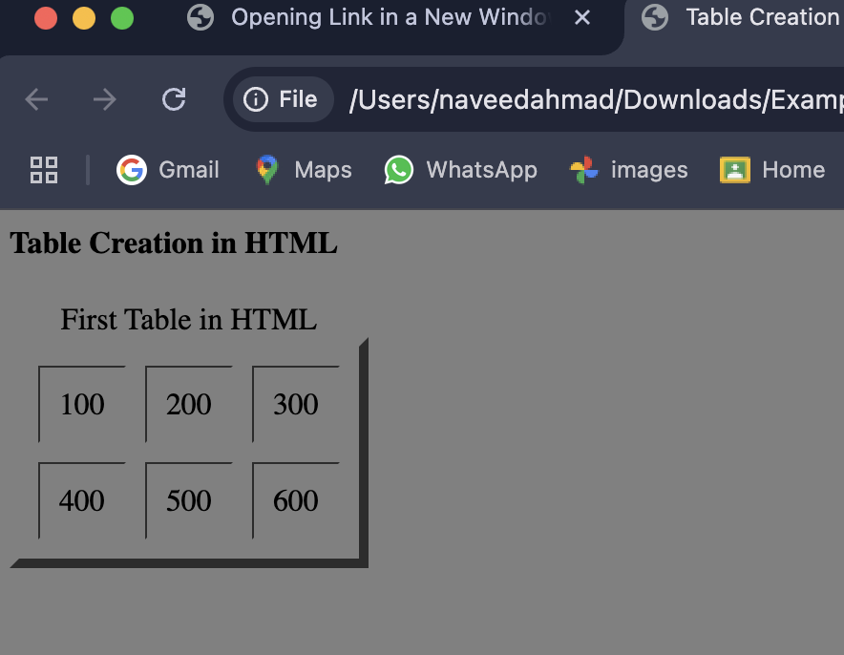

Example 10:

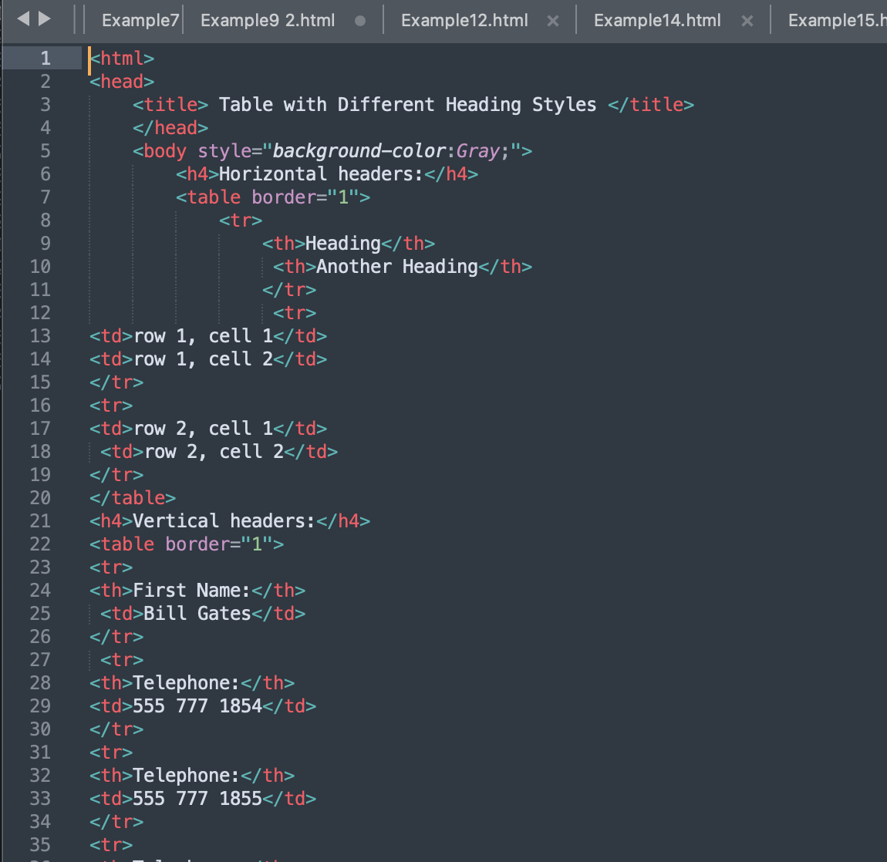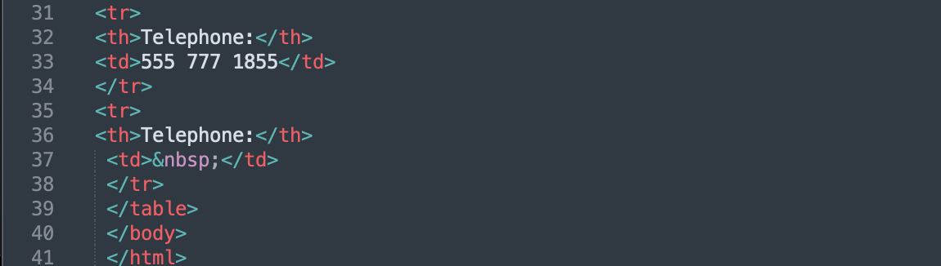

* Shows how to use <th> for table headers.
* Demonstrates horizontal and vertical headings in a table.

Output:

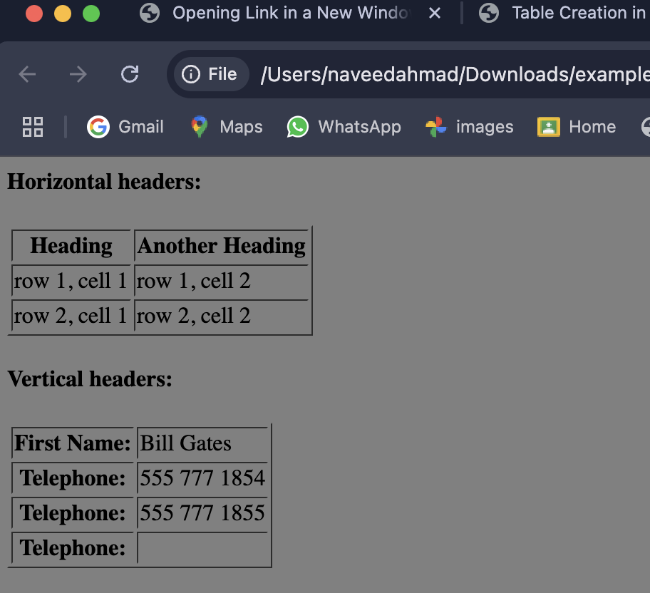

Example 11:

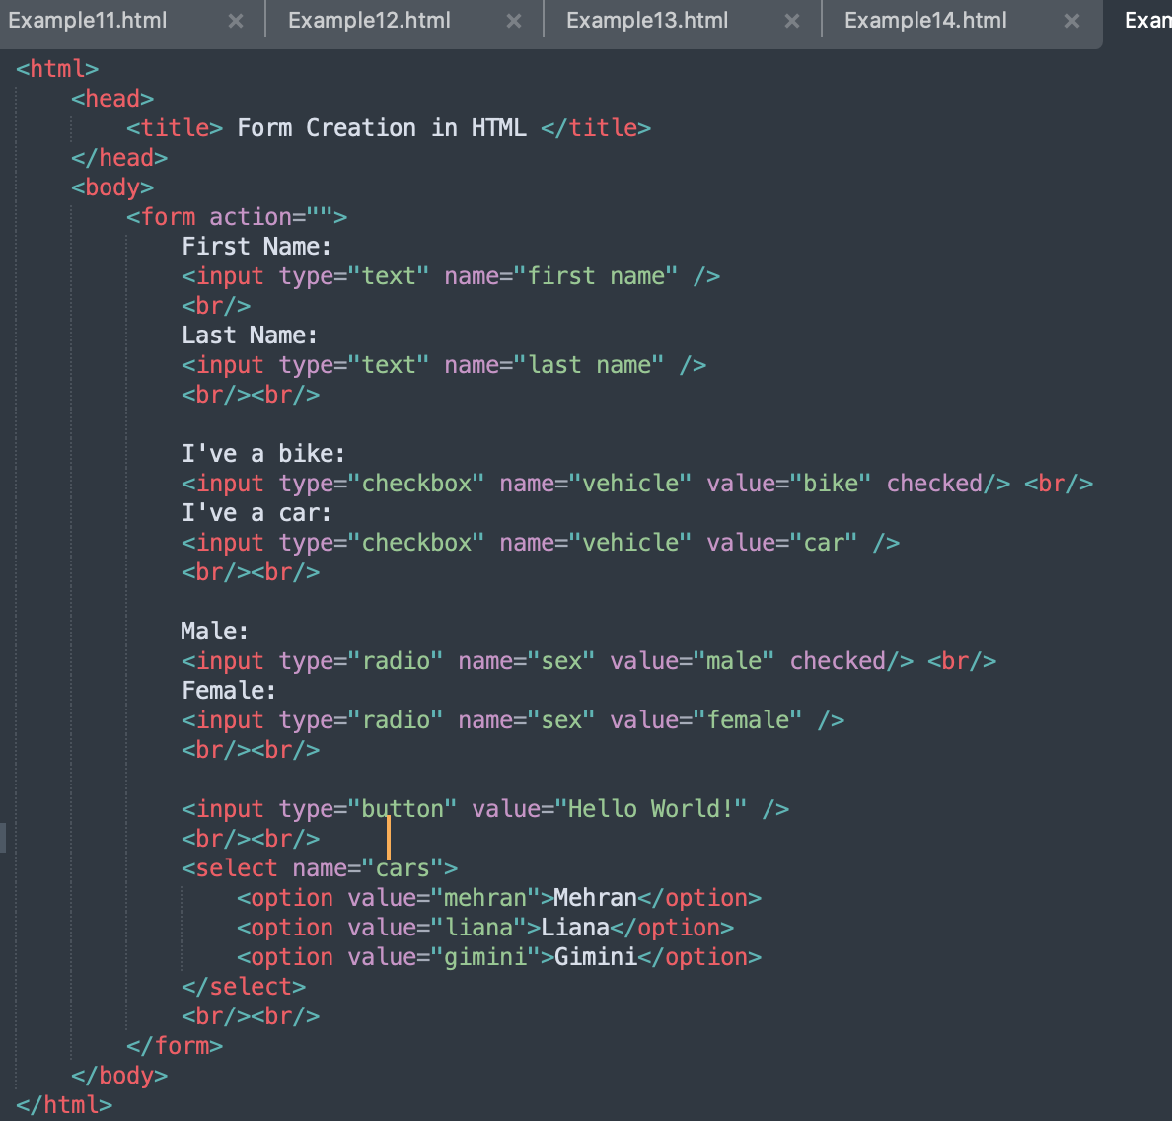

* Demonstrates different frame options (border, box, void, above, etc.) for table borders.

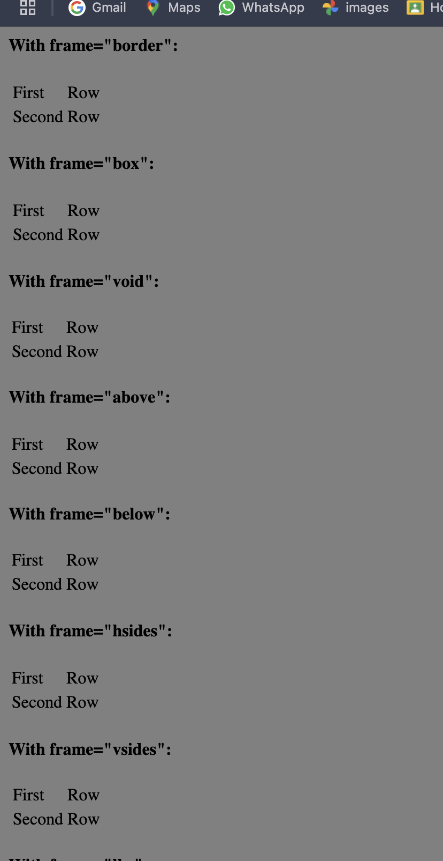

Example 12:

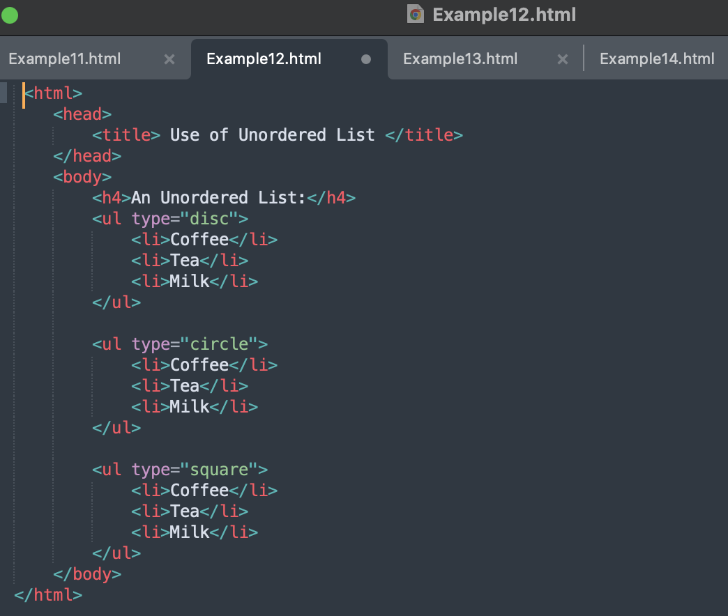

* Shows how to create unordered lists using the <ul> and <li> tags.
* emonstrates different bullet types (disc, circle, square).

output:

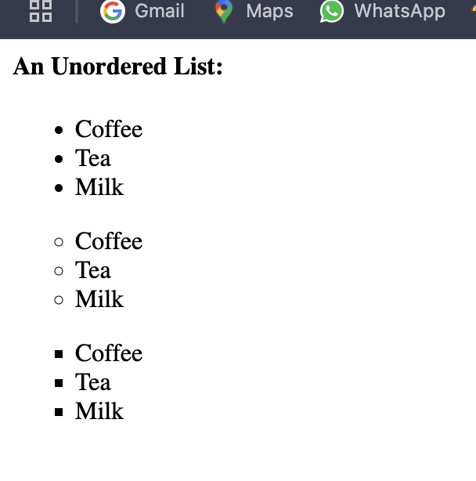

Example 13:

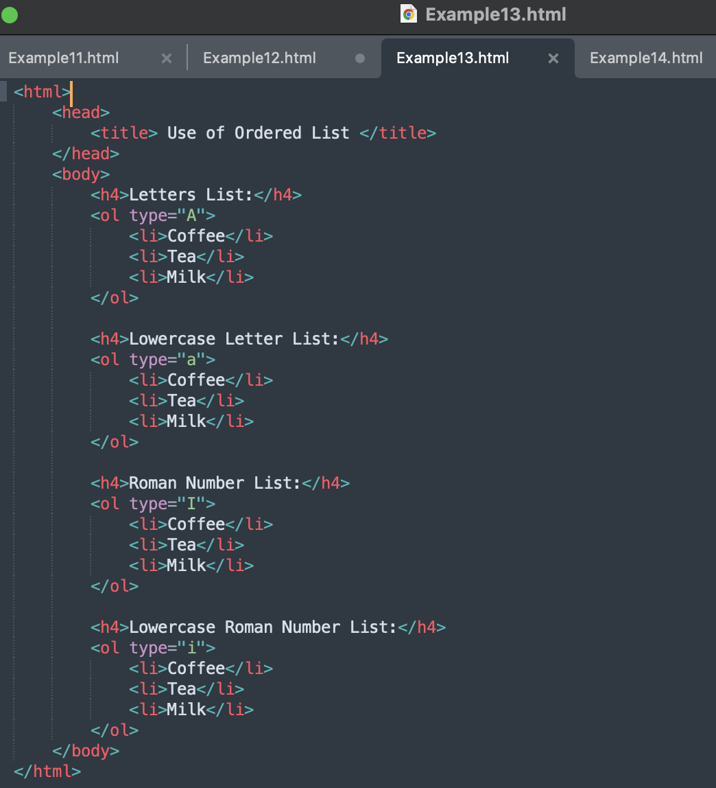

* Demonstrates the use of <ol> and <li> tags to create ordered lists.
* ows different numbering types (A, a, I, i).

Output:

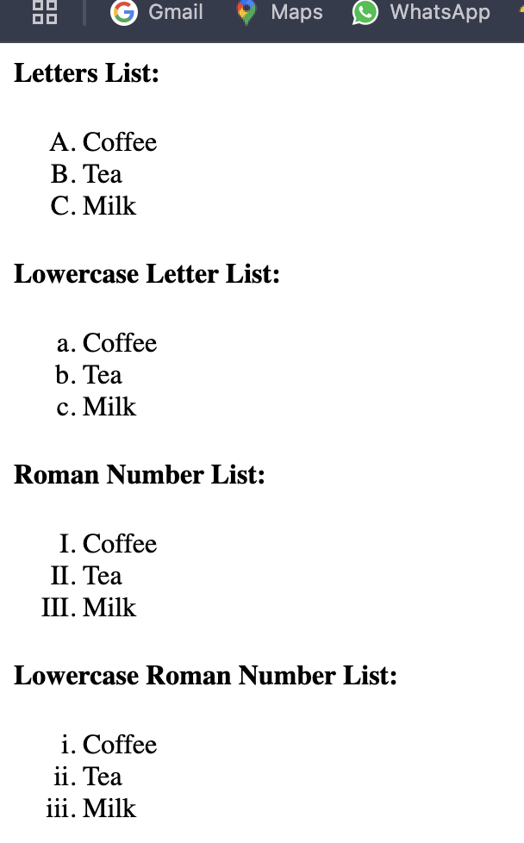

Example 14:

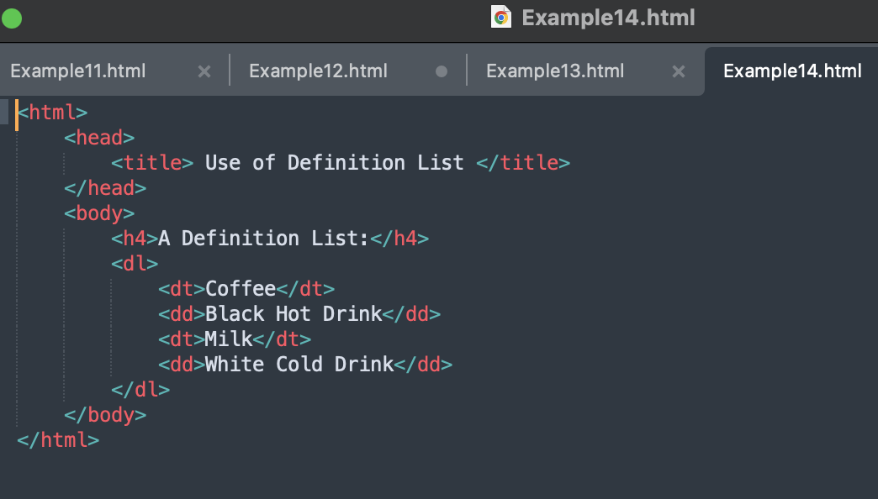

* Demonstrates creating definition lists using <dl>, <dt> (definition term), and <dd> (definition description).

Output:

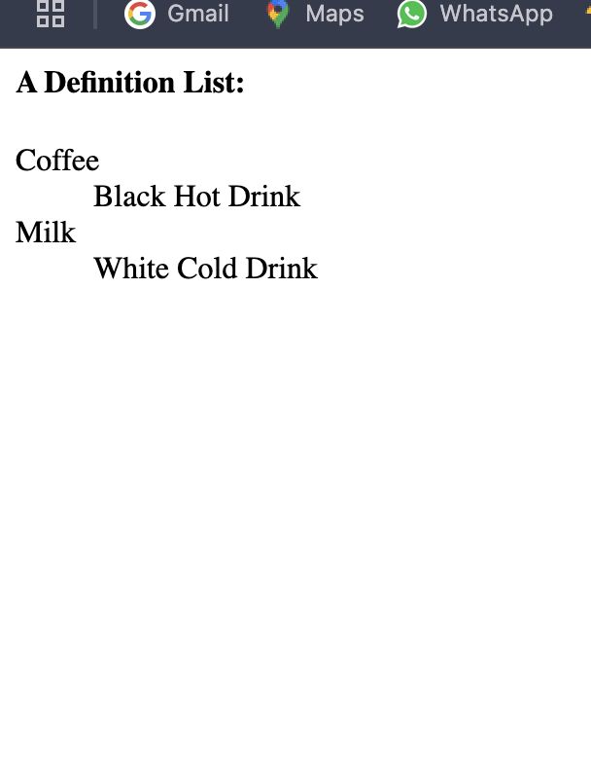

Example 15:

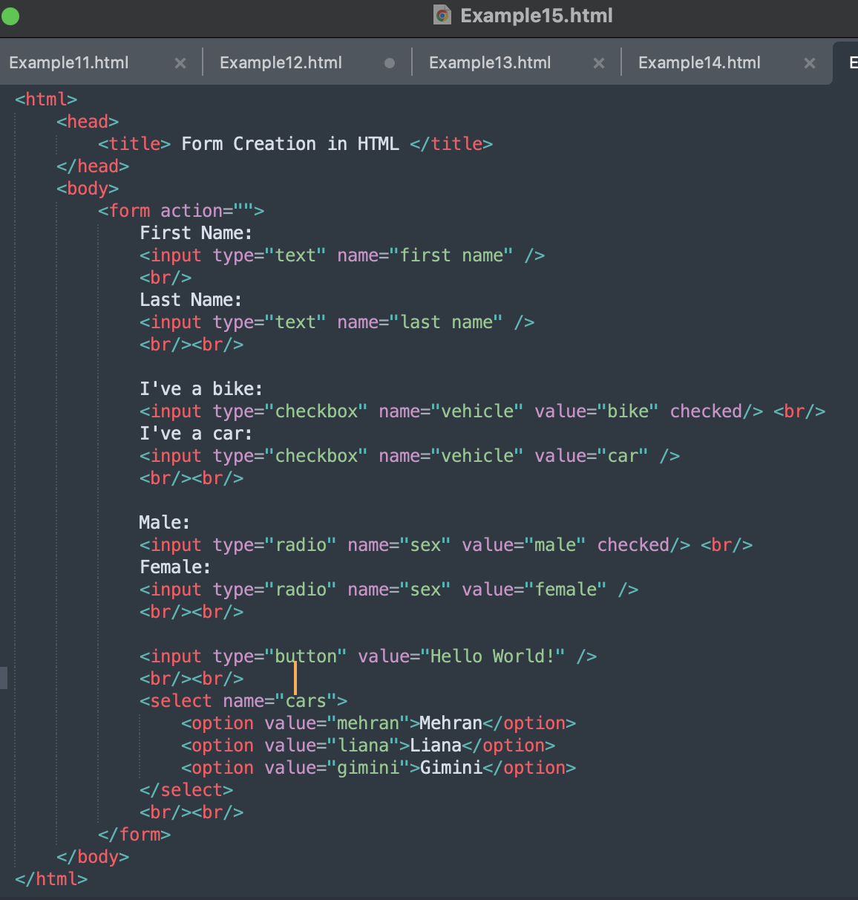

* Demonstrates creating a simple form with text inputs, checkboxes, radio buttons, buttons, and dropdowns using the <form> and <input> tags.

Output:

